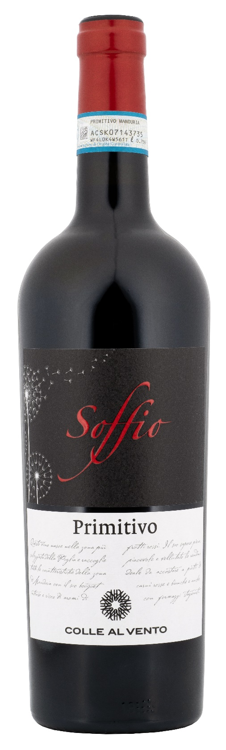
PRIMITIVO DI MANDURIA DOP – SOFFIO

Grape: Primitivo 100%
Alc. Vol.%: 15
Vintage: 2024
Residual sugar g/l: 9,0
Total acidity g/l: 6,2
Region: Apulia
Production zone: Vineyards in the area of Manduria and Sava (Taranto)
Capacity: 750ml

CHARACTERISTICS

Vinification: After a soft pressure and the separation of grape-stalk, traditional maceration and short fermentation at a controlled temperature. To better extract colour and tannins, it is pumped over several times
Aging: 8 months
Yield per ha: 9000kg
Colour: Intense ruby red with purple reflections
Bouquet: Intense, aroma of red berries such as cherries and raspberry and vanilla
Flavour: Round, pleasant and velvety, long-lasting final

SERVING SUGGESTIONS

Excellent with meat, venison and matured cheese.
Serving temperature 18 °C
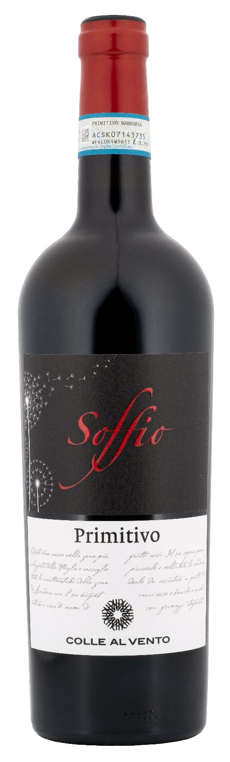
TECHNICAL INFORMATION / PALLETIZING

Size 750ml:
Article Nr. V03001A
GTIN-13 bottle 8017868004684
GTIN-13 carton 8017868004691
Closure Cork
Bottles / carton 6 bottles
Pallet size 80x120cm
Cartons/layer 21
Cartons/pallet 105
Kg/carton 8,1
Kg/pallet 870

Contains sulphites
GMO Free
Revisione 01. 14.05.2026

